Implications for the importance of ceramide synthesis and metabolism in the Pacific oyster (*Crassostrea gigas*) stress response

Emma Timmins-Schiffman*1 and Steven Roberts1

1University of Washington

School of Aquatic and Fishery Sciences

Seattle, WA 98105

#figures, graphs, and charts

Ceramide synthesis and metabolism in oyster stress

ABSTRACT

Ceramide synthesis and metabolism are key components of the vertebrate stress and immune responses and appear to be significant in invertebrates as well.  Four genes involved in the ceramide biosynthesis pathway - *serine palmitoyltransferase-1, 3-ketodihydrosphingosine reductase, acid ceramidase, and ceramide glucosyltransferase* - were characterized in the Pacific oyster, *Crassostrea gigas*.  Full-length cDNA was sequenced for each of the genes, and conserved domains were identified.  Gene expression profiles of the four genes were assessed across different body tissues in *C. gigas*.  The role of the ceramide pathway genes in the invertebrate immune response was also explored by measuring the expression levels of each gene in *Vibrio vulnificus*-exposed juvenile oysters.  The genes involved in the ceramide pathway show high degrees of conservation across taxa in both form and function.  Overall, highest levels of expression were seen in the gill tissue, which is expected for genes that respond to environmental stress.  One gene involved in hydrolytic breakdown of ceramide - *acid ceramidase*  - was upregulated in a bacterial challenge, which is further evidence for the role of ceramide in the invertebrate stress and immune responses.

INTRODUCTION

Ceramide is a sphingolipid that serves as an a important signaling molecule for a variety of cellular processes including differentiation, proliferation, inflammation, and apoptosis (reviewed in Hannun ‘94 and Ballou et al. ‘96). Processes for which ceramide is an effector molecule indicate the importance of ceramide across a variety of life stages and environmental conditions.  Accumulation of ceramide can halt embryonic development (Eliyahu 2007), inhibit insulin signaling (Chavez et al. 2005), and promote apoptosis during cellular stress (Perry et al. 2000).  The production of ceramide can be triggered by various pathways and is sensitive to exogenous stressors (Strelow et al. 2000; Perry et al. 2000).   In leukemia cells exposed to environmental stressors (i.e. ionizing radiation, hydrogen peroxide, UV radiation, and heat shock) all cells had elevated levels of ceramide as well as increased apoptosis. (Verheij et al. ‘96).  In sea bass, changes in intracellular ceramide in gills were associated with abrupt shifts in environmental salinity (El Babili et al. ‘96).

In addition to increasing apoptosis, ceramide has been shown to be associated with a number of other immune-related processes. Cytokines can trigger sphingomyelin hydrolysis, suggesting that ceramide could propagate cytokine signaling (Ballou et al. ’96). Ceramide also plays a key role in the inflammatory response by stimulating IL-1 mediated prostaglandin E2 production and increased expression of cyclooxygenase mRNA and protein (Ballou et al. ’92).

Ceramide can be synthesized *de novo* (Hannun ‘94) or through enzymatic catabolism of sphingolipids (Ballou et al. ‘96).  While the role of ceramide as a signalling molecule in response to stressful conditions has been well studied in mammalian systems there is little information on the function and metabolism of ceramide in aquatic invertebrates.  Recently, Le Grand et al. (2011) discovered that ceramide-based phosphosphingolipids are an important component of Pacific oyster hemocyte membranes.  Given the range of environmental conditions experienced by intertidal species, ceramide signaling is potentially a key component in the cellular response to these environmental changes.

In order to better understand what role ceramide might have in the physiology of Pacific oyster (*Crassostrea gigas*) the current study sets out to characterize genes associated with ceramide synthesis and metabolism in this species. Additionally, oysters were exposed to *Vibrio vulnificus* and the expression levels of four genes involved in the ceramide pathway were assessed with qPCR to provide information on the role of the ceramide synthesis and metabolism in the invertebrate immune response.

MATERIALS AND METHODS

*Gene discovery*

   To identify *Crassostrea gigas* genes involved ceramide metabolism publicly available sequence data were searched for sequences based on homology with sequences in other species.  Short read sequencing data from a 6-day old *C. gigas* larvae transcriptome library were downloaded from NCBI’s Short Read Archive (Accession Number SRX032364). In addition, Expressed sequence tags (ESTs) from NCBI’s GenBank database were downloaded locally. Short reads were quality trimmed and *de novo* assembled using CLC Genomics Workbench v3.7.  Contigs and ESTs were compared to UniProtKB/Swiss-Prot database using NCBI’s BLAST algorithim (Altschul et al. ‘97). Top blast hits were screened for genes associated with ceramide synthesis and metabolism with an e-value cut-off of 10-30.  These genes were chosen based on a pathways involved in ceramide synthesis and metabolism in vertebrates.

*Gene Sequencing*

Juvenile *C. gigas* were obtained from Taylor Shellfish and tissues (gill, mantle, adductor muscle, and digestive gland) were dissected using sterile techniques.  The tissues were stored in RNAlater (Ambion, Carlsbad, CA) until analysis. RNA isolation was carried out using Tri-Reagent (Molecular Resources Center, Cincinnati, OH) as per manufacturer’s protocol. Following RNA isolation, samples were treated with Turbo DNA-free Kit (Ambion) according to manufacturer’s protocol to remove any potential genomic DNA carry-over.  All samples were evaluated to insure genomic DNA was absent by performing qPCR on DNAsed RNA samples.

For genes where the putative open reading frame could be determined based on sequence alignments, PCR primers were designed to amplify entire coding regions (Geneious Pro v. 4.8.5, Drummond et al. 2010) (Table 1).   RNA samples were reverse transcribed to generate cDNA template for PCR using M-MMLV reverse transcriptase according to manufacturers protocol (Promega, Madison, WI).  PCR reactions (25ul) on pooled cDNA were carried out with 12.5 µL Apex TaqRED master mix (Genesee Scientific, San Diego, CA), 8.5 µL Nanopure water, 0.5 µL of each 10 µM primer (Invitrogen, San Diego, CA), and 3 µL cDNA template.  The thermalcycler protocol was as follows: 95°C for 10 minutes; 40 cycles of: 95°C for 30 seconds, 55°C for 30 seconds, and 72°C for 30 seconds; 72°C for 10 minutes.  PCR products were separated on agarose gels, appropriate sized bands were excised, and cloned in pCR ® 2.1-TOPO Vector and transformed in to One Shot Top10 chemically competent cells using the TOPO TA Cloning Kit (Invitrogen). Plasmid DNA was isolated from the bacterial cultures using the Qiagen MiniPrep Kit (Qiagen, Valencia, CA) and sequenced at the High Throughput Genomics Unit (University of Washington).

Sequences were trimmed and translated (Geneious Pro v. 4.8.5, Drummond et al. 2010).  Sequence alignments were performed using ClustalX v. 2.1 (Larkin et al. 2007).

*Protein phylogeny*

Translated protein sequences for four genes were aligned with homologous sequences in other organisms to determine the evolutionary relationship. Using NCBI’s HomoloGene, protein sequences for the desired genes in *Homo sapiens*, *Mus musculus*, *Danio rerio*, *Xenopus tropicalis* and *Caenorhabditis elegans* were downloaded where available.  Using the PhyML plugin in Geneious (Guindon & Gascuel 2003; Drummond et al. 2010), maximum likelihood phylogenetic trees of the protein sequences were constructed based on the James-Taylor-Thornton (JTT) model and bootstrapped 100 times (Guindon & Gascuel 2003; Jones et al. ‘92).

*Quantitative PCR*

Quantitative PCR was carried out in order to characterize relative gene expression across tissues. DNA-free RNA was reverse transcribed to complementary DNA (cDNA) as described above. Quantitative PCR was performed using 1µL of cDNA in a 25uL reaction containing 12 µL of 2x Immomix Master Mix (Bioline, London, UK), 0.5 µL  each of forward and reverse primers (Invitrogen), 1.0 µL SYTO13 (Invitrogen), and 9.5 µL Nanopure water.  Thermal cycling and fluorescence detection was performed using an CFX96 (Bio-Rad, Hercules, CA).  Cycling parameters were as follows: 95°C for 10 mins.; 40 cycles of: 95°C for 15s, 55°C for 15s, 72°C for 30s. Immediately after cycling, a melting curve protocol was run to verify that a single product was generated in each reaction. RNA samples were analyzed to ensure absence of DNA carryover.

Average Ct (fluorescence-based cycle threshold) values across replicates and average gene efficiencies were calculated in PCR Miner (Zhao & Fernald 2005, http://www.miner.ewindup.info/version2).  Gene expression (R0) was calculated based on the equation R0 = 1/(1+E)Ct, where E is the average gene efficiency and Ct is the cycle threshold for fluorescence.  All expression values were normalized to expression in the housekeeping gene *elongation factor 1*.   All qPCRs were run in duplicate and significant differences in expression were determined via pairwise t-tests in R with α=0.05.

*Bacterial Challenges*

Juvenile *C. gigas* (mean length = 11.4 mm, mean width = 6.1 mm, mean depth = 3.3 mm) were obtained from Taylor Shellfish (Quilcene, WA).  For bacterial challenges, *Vibrio vulnificus* was grown from plated cultures in 400 mL culture (1x LB, 1% NaCL) at 37°C for 18 hours at 150 rpm.  The culture was pelleted at 4300 rpm (25°C), the supernatant was removed and pelleted bacteria were resuspended in 50 mL of seawater.  Sixteen oysters in 8 L of seawater were subjected to *V. vulnificus* challenge( 4.56x1019 cfu/L ) via a 3 hour immersion bath.  Control oysters (n=16) were likewise placed in 8L of seawater.  Following exposure, oysters were shucked and gill tissue was dissected from 8 oysters from each treatment and immediately frozen on dry ice to be stored at -80°C.  RNA isolation, reverse transcription and quantitative PCR analysis was carried out as described.

RESULTS

*Gene Discovery*

A total of 23 sequences associated with ceramide metabolism were identified in publicly available sequence databases and are listed in Table 2 and depicted in Figure 1.  Most of these sequences were assembled from 454 short read archive data (Accession Number SRX032364).  Corresponding sequences derived from sequence assembly (i.e. contigs) are provided in supplementary material (S-Table 1).   Of the 23 sequences, 4 were selected for further characterization based on the percent of putative open reading frame identified. These four genes include *Crassostrea gigas* homologs for Serine palmitoyltransferase 1 (Cg-*sptlc1)*, 3-ketodihydrosphingosine reductase (Cg-*3KDSR)*, Acid ceramidase (Cg-*AC),* and Ceramide glucosyltransferase (Cg-*GlcCer)*.

Based on sequence alignments complete open reading frames were obtained for Cg-*sptlc1* (Accession Number JN315146), Cg-*3KDSR* (Accession Number JN315143), and Cg-*AC* (Accession Number JN315144).  Cg-*GlcCer* (Accession Number JN315145) sequence is missing some of the 3’ end. The nucleotide sequences for these genes are in supplementary material S-Figure 2-5.

Cg-*sptlc1* sequencing yielded 1404 bp and was most similar to *sptlc-1* in *Xenopus tropicalis* (Accession Number NM_001079574) with 71% sequence similarity (evalue = 5e-84).  Interestingly, the next most similar sequence is from the hemichordate, *Saccoglossus kowalevskii* (Accession Number XM_002730516 with 70% identity and evalue = 6e-83).  At the amino acid level this sequence is most similar to a protein in the Sumatran orangutan, *Pongo abelii* (Accession Number Q5R9T5), followed by Sptlc-1 from *Macaca fascicularis* (Accession Number Q60HD1, both with evalues of 0.0 and 60% identity).

Compared to 60% similarity the Cg-*sptlc1* translation shares with *H. sapiens* and other related mammals, the *C. gigas* sequence shares 51.0% pairwise identity over 475 amino acid residues with the *C. elegans* Sptlc1.  Cg-*sptlc1* also shares a pyridoxal 5’-phosphate binding pocket with other vertebrate sequences, including *H. sapiens* (residues 173-174, 177, 251, 280, 283, 312 and 315 on the amino acid alignment, Figure 2).  This binding pocket is an important component in a number of intracellular enzymatic reactions.    Cg-*sptlc1* was expressed the most highly in gill tissue, followed by digestive gland, mantle, and then adductor muscle (data not shown).  The fold-over-minimum expression level in the gill compared to the adductor was 47.7.  Cg-*sptlc1* was expressed 1.3-fold higher in the gill tissue of *V. vulnificus*-exposed oysters compared to controls, but this difference was not significant (p=0.068; Figure 6).

Cg-*3KDSR* mRNA sequence is 1129 bp and is most similar to the *Rattus norvegicus* *3KDSR* sequence (NM_001108342, evalue = 1e-32) with a sequence identity of 68%.  The secondmost similar sequence is *3KDSR* from *Saccoglossus kowalevskii* (SM_002740331, evalue=2e-30, sequence identity of 76%).  The high similarity to both vertebrate and invertebrate sequences shows conservation of coding sequence across taxonomic groups.  Blastp of the translated amino acid sequence of Cg-*3KDSR* returns a top hit of *Mus musculus* 3KDSR (Q6GV12, e-value=1e-122) followed by 3KDSR from H. sapiens (Q06136, e-value=3e-121).

Over their entire sequence, the amino acid sequences for *H. sapiens* and *C. gigas* 3KDSR share 50.8% identity.  The translated Cg-*3KDSR* also possesses a conserved catalytic site and a NADH/NADPH binding site and active site motif (Kihara & Igarashi 2004), marked with an asterix and diamond, respectively, on Figure 3.  Cg-*3KDSR* was expressed the most in the gill tissue at greater than 2000-fold more than the expression in the adductor muscle.   Expression of Cg-*3KDSR* in the other tissues was almost undetectable.  Cg-*3KDSR* was expressed 1.6-fold higher in the *Vibrio*-exposed oysters, but this difference in expression was not significant (p=0.079; Figure 6).

The coding sequence for Cg-*AC* is 1170 bp in length and is most similar to a gene up-regulated in *Sebastes* *schlegelii* (Schlegel’s black rockfish) after treatement with lipopolysaccharides, with a sequence similarity of 67% (Accession Number AB491143, e-value = 6e-63).  The next most similar sequence is *Danio* *rerio* acid ceramidase (Accession Number BC165787, e-value = 3e-47, sequence identity 67%).  The translated protein sequence for *C. gigas* is the most similar to the *Rattus norvegicus* acid ceramidase with an e-value of 2e-146 (Accession Number Q6P71).  The next most similar sequence is acid ceramidase from *Pan troglodytes* (Accession Number A5A6P2, e-value of 5e-146).  The Cg-*AC* translation has a conserved domain that includes two closely related proteins: acid ceramidase and N-acylethanolamine-hydrolyzing acid amidase (NAAA; Figure 3).  Over the 246 amino acids of the conserved domain, *C. gigas* AC shares 58.5% identity with *H. sapiens* (Figure 3).  NAAA is a glycoprotein that plays an important role in immune function.

The Cg-*AC* amino acid sequence shares 46.6% pairwise identity over 402 residues with *C. elegans* and 49.4% identity with the *H. sapiens* sequence over 398 residues (Figure 4).  Cg-*AC* was expressed the most in the gill (2.5-fold more than in adductor muscle), followed by digestive gland, mantle, and adductor.  The expression of Cg-*AC* is significantly higher (1.4-fold) in *Vibrio*-exposed oysters compared to controls (p=0.045; Figure 6).

Cg-*GlcCer* mRNA sequence is 1124 bp and is most similar to ceramide glucosyltransferase from the human body louse, *Pediculus humanus corporis* (Accession Number SM_002431306, e-value = 4e-21, sequence identity 66%), followed by *Xenopus laevis* UDP-glucose ceramide glucosyltransferase (Accession Number NM_001090475, e-value = 2e-19, sequence identity of 66%).  The translated amino acid sequence is most similar to *Xenopus tropicalis* ceramide glucosyltransferase (Accession Number Q5BL38, e-value = 9e-122), followed by GlcCer of *X. laevis* (Accession Number Q5U4S8, e-value = 2e-121).

*C. gigas* and *H. sapiens* share a 45.9% pairwise amino acid identity over 396 residues, while *C. elegans* and *C. gigas* share 40.9% pairwise identity over 468 residues (Figure 5).  Cg-*GlcCer* has a similar expression profile across tissues to Cg-*sptlc1* and Cg-*AC*, the highest expression being in the gill (27.9-fold over minimum), followed by digestive gland, mantle and adductor.  It is not expressed differently in *Vibrio*-exposed compared to control oysters (p=0.47; Figure 6).

All four genes show similar phylogenetic topologies (Figure 7).  When the *C. elegans* sequence was included, it clustered with the *C. gigas* sequence with a bootstrap value of 100%.  Similarly, *H. sapiens* and *M. musculus* sequences always clustered together with a bootstrap of 100%.

DISCUSSION

These are the first genes directly involved in ceramide synthesis and metabolism that have been characterized in a mollusc.  We have identified four major components of the ceramide biosynthesis pathway in *Crassostrea gigas*, using laboratory and *in silico* analysis: *serine palmitoyltransferase-1* (Cg-*sptlc1*), *acid ceramidase* (Cg-*AC*), *3-ketodihydrosphingosine reductase* (Cg-*3KDSR*), and *ceramide glucosyltransferase* (Cg-*GlcCer*).  The discovery of these genes in *C. gigas* adds to a growing group of apoptosis-related genes in molluscs (Lee et al. 2011; Zhang et al. 2011; Romero et al. 2011).  In vertebrates, the genes described here are directly responsible for generation of ceramide in *de novo* synthesis (*sptlc, 3KDSR*) and generation of sphingolipids from ceramide (*AC* and *GlcCer*), although further investigation will confirm their specific roles in invertebrates.  *In silico* analysis of the *C. gigas* transcriptome also shows that there are a number of other genes in this same ceramide biosynthesis pathway that have not yet been fully characterized.

*Gene Structure and Function*

*C. gigas* has genes that are show evidence of homology to a majority of the proteins and enzymes in the ceramide pathway (Figure 1).  Other genes that are most likely involved in ceramide synthesis and metabolism, but have yet to be thoroughly characterized, were identified through *in silico* analysis of *C. gigas* 454 contiguous sequences of larval sequences and through blast searches based on homology.  We identified almost all the enzymes necessary for *de novo* ceramide synthesis in vertebrates, suggesting the conservation of this segment of the pathway in Pacific oysters.  We also identified a number of enzymes responsible for transformation of ceramide into other lipid products: ceramide kinase (leads to ceramide 1-P), ceramide synthase (sphingosine), and sphingomyelin synthase (sphingomyelin).  Also identified were a variety of caspases, TNF superfamily receptors, RIP and FADD subunits of the TNFa receptor, which are key components of the cellular stress and apoptotic responses.  A few components of the overall ceramide pathway were not found in our searches and they either do not exist in *C. gigas*, have not been sequenced, or the potential fragmented nature of EST gene sequences make them unidentifiable via homology searches.

The discovery of the enzymes that regulate generation and transformation of ceramide are of particular importance in understanding *C. gigas*‘s response to its environment since these are part of a growing suite of genes that will respond and adjust to changes.  The expression of genes occurs in the oysters at multiple stages since many of them were discovered from EST fragments in the larval transcriptome and the same primers used in this study successfully amplified them in larval cDNA (E. Timmins-Schiffman, unpubl. data).  Genes in the ceramide pathway are essential to development in a number of vertebrates (e.g. Yabu et al. 2001; Eliyahu et al. 2007) and the presence of these genes in the oyster provides evidence of their importance in invertebrate development as well.  Below we discuss in detail the four genes characterized in this study and their potential roles in oyster physiology.

Serine palmitoyltransferase catalyzes the first step of ceramide *de novo* biosynthesis: the condensation of serine and palmitoyl-CoA to 3-ketosphinganine (reviewed in Hannun ‘94; Figure 1).  Sptlc mediates the rate-limiting step in the pathway of *de novo* ceramide biosynthesis (Merrill et al. ‘85; Perry 2002).  There are two forms of *H. sapiens* Sptlc – LCB1 and LCB2.  The H. sapiens LCB1, shown in the alignment (Figure 2), has a putative transmembrane domain starting at residue 21 and extending 21 amino acids (Hanada 2003).  *C. gigas* protein shares 11 of those 21 amino acids, suggesting that it may have a similar topology.  The mammalian transmembrane domain spans the endoplasmic reticulum, with the N terminus within the ER (Yasuda et al. 2002; Hanada 2003).  LCB2 has a conserved motif that binds pyridoxal phosphate (PLP) (Hanada 2003), but the Sptlc form LCB1 has an asparagine instead, which is also found in our *C. gigas* sequence (residue 315 in our alignment, Figure 2).  Another pyridoxal 5’-phosphate binding pocket is made from *H. sapiens* residues numbered 173-174, 177, 251, 280, 283, 312 and 315.  *C. gigas* Sptlc1 has identical amino acids at all of these locations, except at residue 312 where it has a S instead of N.  The basic function of Sptlc is conserved across taxa and is instrumental in determining levels of ceramide and other sphingolipid intermediates (Hanada 2003).  The expression of Sptlc mRNA and protein in vertebrates is sensitive to a number of biological processes, including stage of development, external stress stimuli, and apoptotic stimuli that activate the enzyme post-transcriptionally (Hanada 2003).  Sptlc1 is responsible for accumulation of intracellular ceramide during cellular stress (Perry et al. 2000; Perry 2002).   These enzymatic functions may be conserved in *C. gigas* considering the degree of homology between the *C. gigas* and *H. sapiens* amino acid sequences: 59.8% pairwise identity (over 479 residues).   The *C. gigas* sequence shares 51.0% pairwise identity over 475 amino acid residues with the *C. elegans* Sptlc1.

The product of the reaction catalyzed by Sptlc is 3-ketosphinganine.  3-ketosphinganine is reduced by a NADPH-dependent reductase to dihydrosphingosine.  The enzyme that catalyzes this reaction is 3-ketodihydrosphingonsine reductase (3KDSR).  This enzyme is much less studied than Sptlc and was not characterized in *H. sapiens* until 2004 (Kihara & Igarashi 2004).  Over their entire sequence, the protein sequences for *H. sapiens* and *C. gigas* 3KDSR share 50.8% identity.   The *C. gigas* protein sequence shares a putative active site motif and a NADH or NADPH binding site with *H. sapiens, M. musculus*, and *D. rerio*.  The active site motif, first identified as being conserved across humans, mice, and yeast, follows the pattern *Tyr-X-X-X-Lys* (Kihara & Igarashi 2004).  All four amino acid sequences in Figure 3 share more of this motif than previously described: *Tyr-Ser-X-Ser-Lys*, beginning at position 187 on the alignment.  The possible NADH or NADPH binding site is characterized by the motif *Gly-Gly-X-X-X-Gly-X-Gly* (Kihara & Igarashi 2004) and begins at position 39.  This motif is actually identical in its entirety – *Gly-Gly-Ser-Ser-Gly-Ile-Gly* – across all four sequences/taxa in Figure 3.  The high degree of conservation for both of these motifs is suggestive of their importance in mechanistic function of 3KDSR.

Acid ceramidases are responsible for the hydrolytic breakdown of ceramide to sphingosine and free fatty acid.  “Acid” refers to the pH optimum of this particular form of the enzyme, with the maximum activity of the *H. sapiens* enzyme occurring at pH 3.8-4.3 (Bernardo et al. ‘95).  *In vitro*, AC can accomplish its reverse reaction as well – the generation of ceramide from sphingosine (Okino et al. 2003).  AC is made up of two subunits: an unglycosylated α-subunit of approximately 13 kDa and a N-glycosylated β-subunit of about 40 kDa (Bernardo et al. ‘95; Koch et al. ‘96).  Four mutations that cause cessation of enzymatic activity (leading to build-up of ceramide) have been identified in *H. sapiens* AC, all of which cause Farber’s Disease resulting in death by a few years of age (Koch et al. ‘96; Li et al. ‘99).  Increased expression of AC has been found to upregulate metabolism of intracellular ceramide in mammals (Strelow et al. 2000; Chavez et al. 2005).  The AC amino acid sequence also contains sequence for a closely related protein: N-acylethanolamine-hydrolyzing acid amidase.  NAAA is an important enzyme in the vertebrate immune response and the *C. gigas* sequence has a 58.5% pairwise identity with the conserved domain in the *H. sapiens* sequence.  Similarly to tissues in *H. sapiens* (Li et al. ‘99), *AC* is expressed in all *C. gigas* tissues investigated here - gill, mantle, digestive gland, and adductor muscle.  The *C. gigas* amino acid sequence shares 46.6% pairwise identity over 402 residues with *C. elegans* and 49.4% identity with the *H. sapiens* sequence over 398 residues.

Ceramide glucosyltransferase, or glucosylceramide synthase, catalyzes the reaction that generates glycosphingolipids (GSLs) from ceramide (reviewed in Ichikawa & Hirabayashi ‘98).  GSLs are important constituents of plasma membranes.  The ubiquitous expression of *GclCer* in *H. sapiens*, coupled with a putative C+G-rich regulatory region in the nucleotide sequence, demonstrates its probable role in cell viability (Ichikawa et al. ‘96).  The structure of the *C. gigas* GlcCer is different from *H. sapiens* in that it does not share the latter’s N-terminal transmembrane domain that spans residues 70-90 in Figure 5 (Ichikawa et al. ‘96).   Despite these differences in topology, *C. gigas* and *H. sapiens* share a 45.9% pairwise amino acid identity over 396 residues.  Compared to 40.9% shared between *C. elegans* and *C. gigas* over 468 residues.  GlcCer is present in all animals and many plants, underlining the universal use of GSLs in plasma membranes (Ichikawa & Hirabayashi ‘98).  GlcCer acts efficiently in response to ceramide accumulation (Ichikawa & Hirabayashi ‘98), which can occur during cellular stress.

*Gene Expression and Role in the Immune Response*

The expression patterns of the four genes described in this paper support that ceramide synthesis and metabolism are important in the *C. gigas* immune response.  Genes important in the oyster immune response are frequently expressed in gill tissue (Seo et al. 2010; Yu et al. 2011; Romero et al. 2011), although this expression pattern could be an artifact of the expression profiles of hemocytes that have infiltrated the gills.  The oyster encounters its environment via its gills, which constitute a large portion of *C. gigas*’s surface area and are constantly filtering water.  Thus, it follows logically that cells in the gills would activate the pathways necessary to respond to an environmental stress.  Given the high degree of identity between oyster and vertebrate genes in this pathway, it is probable that changes in ceramide metabolism are important in the Pacific oyster response to environmental stressors.

After 3 hours of exposure to *Vibrio vulnificus*, only one ceramide metabolism gene (Cg-*AC*) was expressed at significantly higher levels in the bacteria-exposed oysters, compared to the control (Figure 6).  The increased expression of Cg-*AC* implies that an accumulation of intracellular ceramide has occurred or is occurring and this excess ceramide needs to be removed.  This probable ceramide accumulation could very well be a stress response to the *V. vulnificus* exposure.  Two of the genes – Cg-*sptlc1* and Cg-*3KDSR*– showed a trend towards greater expression compared to oysters that were not exposed to *V. vulnificus* (although the expression difference was nonsignificant at  p>0.05; Figure 6).  This could be a signature of feedback inhibition since ceramide accumulation (possibly via *de novo* synthesis) has already occurred and further ceramide production is no longer warranted.  The lack of difference in Cg-*GlcCer* gene expression, which catalyzes the generation of glycosphingolipids from ceramide, possibly indicates that Cg-*AC* is the preferred pathway for the degradation of accumulated ceramide in this particular physiological situation.  It is also possible that even though there is little evidence for differences in transcription of DNA to mRNA, active and differential translation from mRNA to protein of already transcribed RNA could be occurring as a response to the *V. vulnificus* exposure.  Similarly, pre-existing ceramide could be redistributed around the cell in response to this stress - a response that would not be measurable by the methods used in this study.

It is possible that our lack of evidence for a strong response to *V. vulnificus* exposure may be due to the fact that *V. vulnificus* is not a pathogen that usually infects *C. gigas*, but rather a pathogen that proliferates within the oyster, which acts as a vector for pathogen transferral (usually to humans).  Also, compared to other studies of immune challenge in oysters where the pathogen is injected, a bath exposure may result in a relative dampening of the effect of the pathogen and/or create more variable and unpredictable results (De Decker et al. 2011).

Caspase-mediated pathways are another route by which stress-induced apoptosis can occur and could be an important stress response mechanism in oysters. Recent studies have found that this type of apoptosis regulation is prevalent in invertebrates and probably instrumental in response to environmental stress.  The disk abalone, *Haliotis discus discus*, constitutively expresses caspase-8, the highest levels being in the gill (Lee et al. 2011).  There is immediate upregulation of this gene in gill tissue and hemocytes following bacterial and viral challenge (Lee et al. 2011).  In addition, four more apoptotic genes were recently described in *C. gigas*: Fas-associated protein with death domain (FADD), inhibitor of apoptosis (IAP), and initiator and effector caspases (Zhang et al. 2011).

Lastly, our exposure may not have been long enough to elicit the full immune response of the oysters.  Other studies (using injected *Vibrio* species) have found significant immune responses from 9 hours to 8 days post-injection, compared to our 3 hours (Labreuche et al. 2006; Badariotti et al. 2007; Gagnaire et al. 2007).    Further research that investigates changes in cellular apoptosis during an immune challenge in *C. gigas* will help to support or refute this role for ceramide generation.  Full characterization of the ceramide pathway will increase our understanding of how *C. gigas*, a commercially and environmentally important species, interacts with its environment and the stressors it encounters therein.

In this study, we characterized the mRNA sequence and expression profiles of four genes related to ceramide synthesis and metabolism.  The results presented above support that ceramide likely plays an important role as a second messenger in molluscs, as it does in vertebrates.  In vertebrates, ceramide is an instrumental cellular messenger during stress and immune challenges.  Further investigations into its roles in the oyster and related invertebrates will elucidate whether or not these functions are conserved across taxa.  In both aquaculture and natural settings, better understanding of how the Pacific oyster interacts with its environment will provide information on how environmental stressors impact the physiology and survival of this key species.

TABLES AND FIGURES

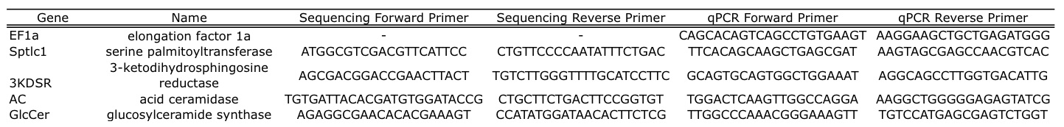

Table 1. Sequencing and qPCR primer sequences for *EF1α*, Cg-*sptlc1*, Cg-*3KDSR*, Cg-*AC*, and Cg-*GlcCer*.

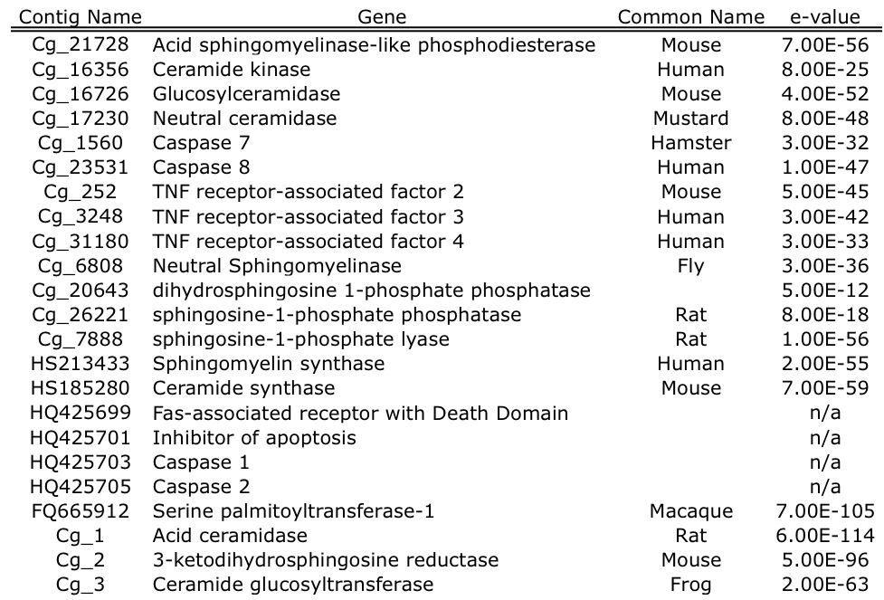

Table 2. Ceramide synthesis and metabolism genes identified in *Crassostrea gigas* through homology searches of publicly available sequences. Sequences that were assembled from 454 data or were sequenced in this study are given a contig number (“Cg_#”). *C. gigas* EST sequences from NCBI that showed homology with ceramide genes are listed with their Accession Number. The top blast hit and evalue are also provided.

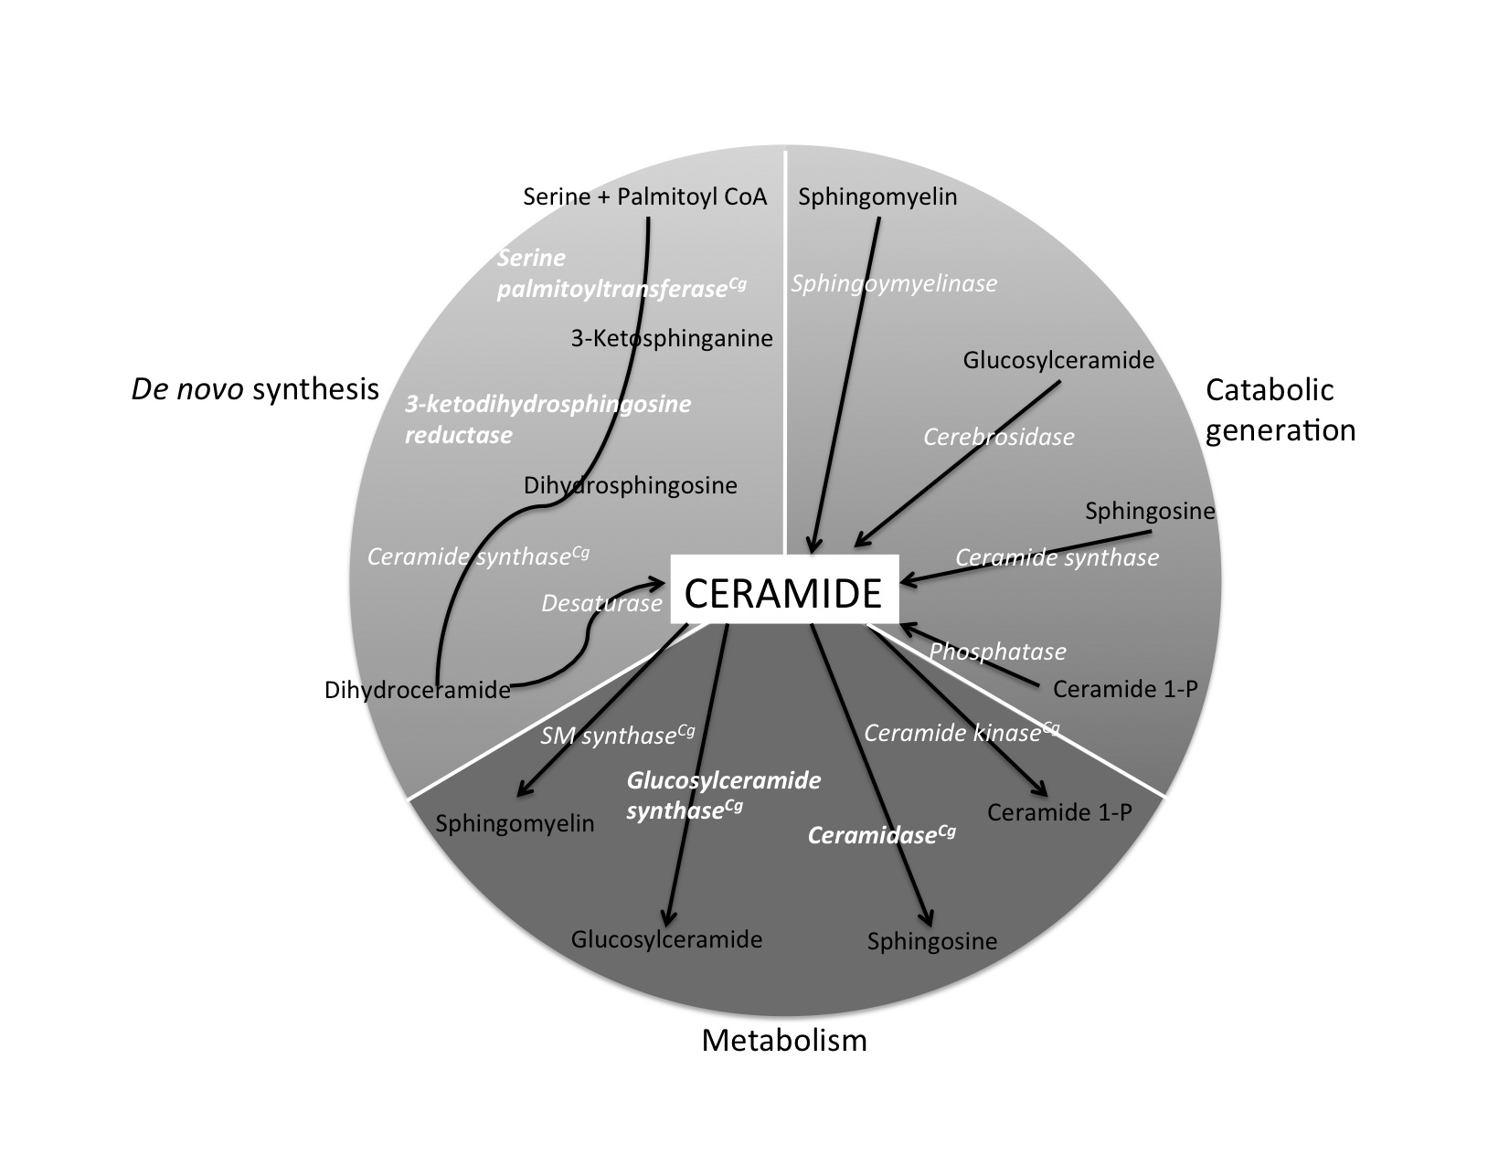

Fig. 1. Representation of the ceramide biosynthesis and metabolism pathway. Enzymes are in white italics; precursors to a metabolic products from ceramide are in black. The pathway is adapted from Ballou et al. (’96) and Hannun and Luberto (2000).



Figure 2. Amino acid alignment of translated Cg-*sptlc1* along with protein sequence of *C. elegans* (Accession Number NP_001021978 ), *H. sapiens* (Accession Number NP_006406), *M. musculus* (Accession Number NP_033295), and *D. rerio* (Accession Number NP_001018307). The transmembrane domain is marked by the dashed box and the asparagine that corresponds to the *H. sapiens* LCB1 isoform is marked with an arrow.



Figure 3. Amino acid alignment of translated Cg-*3KDSR* with protein sequence from *H. sapiens* (Accession Number Q06136), *M. musculus* (Accession Number NP_081810), and *D. rerio* (Accession Number NP_957433). The transmembrane domain is marked by a dashed box. The conserved catalytic site is marked with an asterix and the NADH/NADPH binding site and active site motif is marked with a diamond.



Figure 4. Amino acid alignment of translated Cg-*AC* with protein sequences from acid ceramidase in *C. elegans* (Accession Number NP_493173), *H. sapiens* (Accession Number NP_808592), *M. musculus* (Accession Number NP_062708), and *D. rerio* (Accession Number NP_001006088). The *H. sapiens* transmembrane domain is indicated by a dashed box.



Figure 4. Amino acid alignment of translated Cg-*GlcCer* with ceramide glucosyltransferase protein sequences from *C. elegans* (Accession Number NP_506971), *H. sapiens* (Accession Number NP_003349), *M. musculus* (Accession Number NP_035803), and *X. tropicalis* (Accession Number Q5BL38).

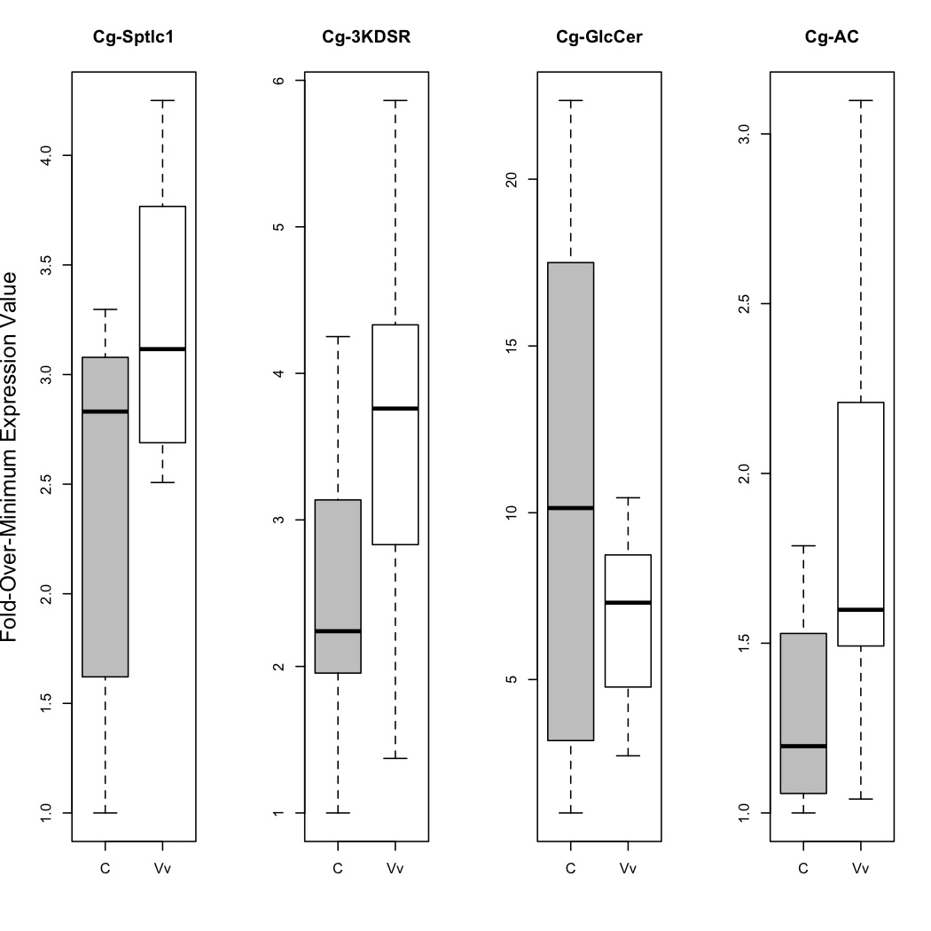

Figure 6. Expression levels in gill tissue for all four genes in control versus *V. vulnificus*-exposed oysters. All response gene expression values were normalized to expression of the housekeeping gene, *EF1α*, and then transformed to fold-over-minimum. The only gene that shows a statistically significant difference in expression at *α* =0.05 is Cg-*AC* (p=0.045).

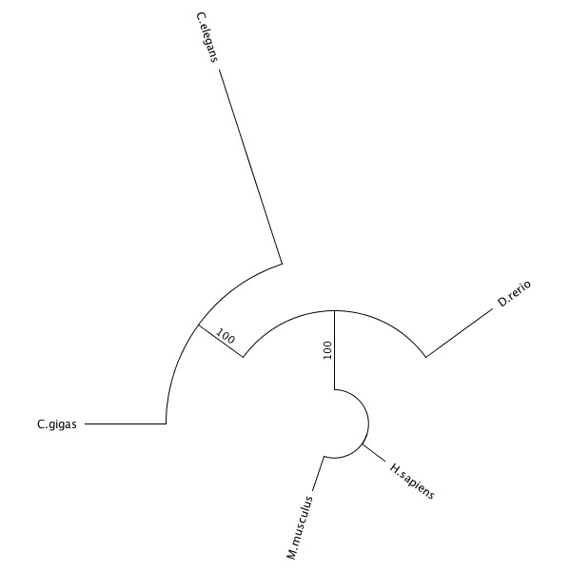

Figure 7. Maximum likelihood phylogenetic tree of the amino acid alignment of acid ceramidase in *C. gigas*, *C. elegans*, *H. sapiens*, *M. musculus*, and *D. rerio*. All other protein trees had similar topology to the one shown. The tree was created based on the James-Taylor-Thornton (JTT) model and bootstrapped 100 times.

LITERATURE CITED

Altschul SF, Madden TL, Schaeffer AA,Zhang J, Zhang Z, Miller W, and Lipman DJ. 1997. Gapped BLAST and PSI-BLAST: a new generation of protein database search programs, Nucleic Acids Res. 25:3389-3402.

Badariotti F, Lelong C, Dubos M-P, and Favrel P. 2007. Characterization of chitinase-like proteins (*Cg*-Clp1 and *Cg*-Clp2) involved in immune defence of the mollusc *Crassostrea gigas*. FEBS Journal. 274: 3646-3654.

Ballou LR, Laulederkind SJ, Rosloniec EF, and Raghow R. 1996. Ceramide signaling and the immune response. Biochimica et Biophysica Acta. 1301(3): 273-287.

Bernardo K, Hurwitz R, Zenk T, Desnick RJ, Ferlinz K, Schuchman EH, and Sandhoff K. 1995. Purification, characterization, and biosynthesis of human acid ceramidase. The Journal of Biological Chemistry. 270: 11098-11102.

Chavez JA, Holland WL, Bär J, Sandhoff K, and Summers SA. 2005. Acid ceramidase overexpression prevents the inhibitory effects of saturated fatty acids on insulin signaling. The Journal of Biological Chemistry. 280: 20148-20153.

David E, Tanguy A, and Morgan D. 2007. Peroxiredoxin 6 gene: a new physiological and genetic indicator of multiple environmental stress response in Pacific oyster *Crassostrea gigas*. Aquatic Toxicology. 84(3): 389-398.

De Decker S, Normand J, Sulnier D, Pernet F, Castagnet S, and Boudry P. 2011. Responses of diploid and triploid Pacific oysters *Crassostrea gigas* to *Vibrio* infection in relation to their reproductive status. Journal of Invertebrate Pathology. 106(2): 179-191.

Drummond AJ, Ashton B, Buxton S, Cheung M, Cooper A, Heled J, Kearse M, Moire R, Stones-Havas S, Sturrock S, Thierer T, and Wilson A. 2010. Geneious v4.5.6. Available from http://www.geneious.com

El Babili M, Brichon G, and Zwingelstein G. 1996. Sphingomyelin metabolism is linked to salt transport in the gills of euryhaline fish. Chemistry and Materials Science. 31: 385-392.

Eliyahu E, Park J-H, Shtraizent N, He X, and Schuchman EH. 2007. Acid ceramidase is a novel factor required for early embryo survival. The FASEB Journal. 21: 1403-1409.

Gaignaire B, Gay M, Huvet A, Daniel J-Y, Saulnier D, and Reanault T. 2007. Combination of a pesticide exposure and a bacterial challenge: *In vivo* effects on immune response of Pacific oyster, *Crassostrea gigas* (Thunberg). Aquatic Toxicology. 84(1): 92-102.

Guindon S and Gascuel O. 2003. A simple, fast, and accurate algorithm to estimate large phylogenies by maximum likelihood. Systematic Biology. 52(5): 696-704.

Haimovitz-Friedman A, Kan CC, Ehleiter D, Persaud RS, McLoughlin M, Fuks Z, and Kolesnick RN. 1994. Ionizing radiation acts on cellular membranes to generate ceramide and initiate apoptosis. The Journal of Experimental Medicine. 180(2): 525-535.

Hanada K. 2003. Serine palmitoyltransferase, a key enzyme of sphingolipid metabolism. Biochimica et Biophysica Acta – Molecular and Cell Biology of Lipids. 1632: 16-30.

Hannun YA. 1994. The sphingomyelin cycle and the second messenger function of ceramide. The Journal of Biochemical Chemistry. 269(5): 3125-3128.

Hannun YA and Luberto C. 2000 Ceramide in the eukaryotic stress response. Trends in Cell Biology. 10(2): 73-80.

Ichikawa S, Sakiyama H, Suzuki G, Hidari KI and Hirabayashi Y. 1996. Expresion cloning of a cDNA for human ceramide glucosyltransferase that catalyzes the first glycosylation step of glycosphingolipid synthesis. PNAS. 93: 4638-4643.

Ichikawa S and Hirabayashi Y. 1998. Glucosylceramide synthase and glycosphingolipid synthesis. Trends in Cell Biology. 8: 198-202.

Jones DT, Taylor WR, Thornton JM. 1992. The rapid generation of mutation data matrices from protein sequences. Comput Appl Biosci. 8: 275-282.

Kihara A and Igarashi Y. 2004. FVT-1 is a mammalian 3-Ketodihydrosphingosine Reductase with an active site that faces the cytosolic side of the endoplasmic reticulum membrane. The Journal of Biological Chemistry. 279:49243-49250.

Koch J, Gärtner S, Li C-M, Quintern LE, Bernardo K, Levran O, Schnabel D, Desnick RJ, Schuchman EH, and Sandhoff K. 1996. Molecular cloning and characterization of a full-length complementary DNA encoding human acid ceramidase: identification of the first molecular lesion causing Farber Disease. The Journal of Biological Chemistry. 271: 33110-33115.

Labreuche Y, Soudant P, Goncalves M, Lambert C, and Nicolas J-L. 2006. Effects of extracellular products from the pathogenic *Vibrio aestuarianus* strain 01/32 on lethality and cellular immune responses of the oyster *Crassostrea gigas*. Developmental & Comparative Immunology. 30(4): 367-379.

Larkin MA, Blackshields G, Brown NP, Chenna R, McGettigan PA, McWilliam H, Valentin F, Wallace IM, Wilm A, Lopez R, Thompson JD, Gibson TJ, Higgins DF. 2007. Clustal W and Clustal X version 2.0. Bioinformatics. 23: 2947-2948.

Le Grand F, Kraffe E, Marty Y, Donaghy L, and Soudant P. 2011. Membrane phospholipid composition of hemocytes in the Pacific oyster *Crassostrea gigas* and the Manila clam *Ruditapes philippinarum*. Comparative Biochemistry and Physiology – Part A. 159(4): 383-391.

Lee Y, De Zoysa M, Whang I, Lee S, Kim Y, Oh C, Choi CY, Y S-Y, and Lee J. 2011. Molluscan death effector domain (DED)-containing caspase-8 gene from disk abalone (*Haliotis discus discus*): Molecular characterization and expression analysis. Fish & Shellfish Immunology. 30(2): 480-487.

Li C-M, Park J-H, He X, Levy B, Chen F, Arai K, Adler DA, Disteche CM, Koch J, Sandhoff K, and Schuchman EH. 1999. The Human acid ceramidase gene (ASAH): structure, chromosomal location, mutation analysis, and expression. Genomics. 62: 223-231.

Marie V, Bonzalez P, Baudrimont M, Boutet I, Moraga D, Bourdineaud J-P, and Boudou A. 2009.. Metallothionein gene expression and protein levels in triploid and diploid oysters *C. gigas* after exposure to cadmium and zinc. Environmental Toxicology and Chemistry. 25(2): 412-418.

Merrill AH, Nixon DW, and Williams RD. 1985. Activities of serine palmitoyltransferase (3-ketosphinganine synthase) in microsomes from different rat tissues. Journal of Lipid Research. 26: 617-622.

Okino N, He X, Gatt S, Sandhoff K. Ito M, and Schuchman EH. 2003. The reverse activity of human acid ceramidase. The Journal of Biological Chemistry. 278: 29948-29953.

Perry DK 2002. Serine palmitoyltransferase: role in apoptotic de novo ceramide synthesis and other stress responses. Biochimica et Biophysica Acta – Molecular and Cell Biology of Lipids. 1585(2-3): 146-152.

Perry DK, Bielawska A, and Hannun YA.. 2000. Quantitative determination of ceramide using diglyceride kinase. Methods in Enzymology. 312: 22-31.

Romero A, Estévez-Calvar N, Dios S, Figueras A, and Novoa B. 2011. New insights into the apoptotic process in mollusks: characterization of caspase genes in *Mytilus galloprovincialis*. PLoS ONE. 6:e17003. doi:10.1371/journal.pone.0017003.

Seo J-K, Stephenson J, Crawford JM, Stone KL, and Noga EJ. 2010. American oyster, *Crassostrea virginica*, expresses a potent antibacterial histone H2B protein. Marine Biotechnology. 12(5): 543-551.

Strelow A, Bernardo K, Adam-Klages S, Linke T, Sandhoff K, Krönke M, and Adam D. 2000. Overexpression of acid ceramidase protects from tumor necrosis factor-induced cell death. The Journal of Experimental Medicine. 192: 601-612.

Verheij M, Bose R, Lin XH, Yao B, Jarvis WD, Grant S, Birrer MF, Szabo E, Zon LI, Kyriakis JM, Haimovitz-Friedman A, Fuks Z, and Kolesnick RN. 1996. Requirement for ceramide-initiated SAPK/JNK signaling in stress-induced apoptosis. Letters to Nature. 380: 75-79.

Yabu T, Kishi S, Okazaki T, and Yamashita M. 2001. Characterization of zebrafish caspase-3 and induction of apoptosis through ceramide generation in fish fathead minnow tailbud cells and zebrafish embryo. Biochem. J. 360: 39-47.

Yasuda S, Nishijima M, and Hanada K. 2002. Localization, topology, and function of the LCB1 subunit of Serine Palmitoyltransferase in mammalian cells. The Journal of Biological Chemistry. 278: 4176-4183.

Yu H, He Y, Wang X, Zhang Q, Bao Z, and Guo X. 2011. Polymorphism in a serine protease inhibitor gene and its association with disease resistance in the eastern oyster (*Crassostrea virginica* Gmelin). Fish Shellfish Immunol. 30(3): 757-762.

Zhang J-Y, Pan M-H, Sun Z-Y, Huang S-J, Yu Z-S, Liu D, Zhao D-H, and Lu C. 2010. The genomic underpinnings of apoptosis in the silkworm, *Bombyx mori*. BMC Genomics. 11: doi:10.1186/1471-2164-11-611.

Zhang L, Li L, and Zhang G. 2011. Gene discovery, comparative analysis and expression profile reveal the complexity of the *Crassostrea gigas* apoptosis system. Developmental and Comparative Immunology. 35: 603-610.

Zhao S and Fernald RD. 2005. Comprehensive algorithm for quantitative real-time polymerase chain reaction. Comput Biol. 12(8): 1045-1062.